- Create a file product.txt using vim editor，first field is product name, 2nd field is unit price and 3rd field is total number of product as the following:

HardDisk:2500:120
HandPhone:15000:75
PC:30000:5
Notebook:45000:12

Please write a BASH SCRIPT to read and output the following:
HardDisk 2500 120 300,000
HandPhone 15000 75 1,125,000
PC 30000 5 150,000
Notebook 45000 12 540,000
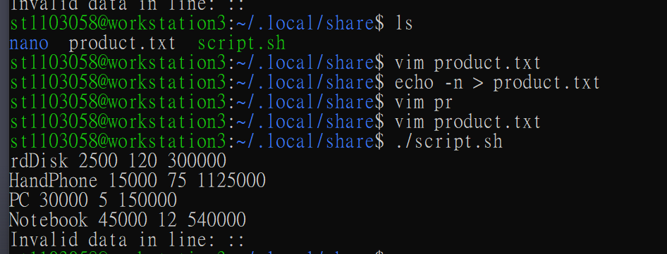

2. Write a BASH SCRIPT to input integer value N and filename。 For example if your input is 5 and filename is book, then the program will create 5 file that is named book1.txt. book2.txt, …, book5.txt.
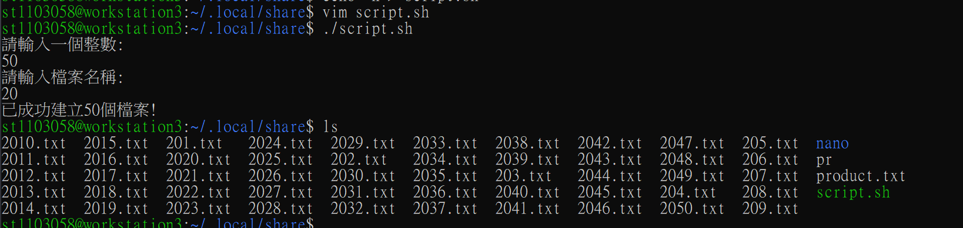

- Create a text file testdata.txt using vim，the first field is name, second field is English score, next one is UNIX score as the following:

john:92:68
mary:86:54
ted:99:12
joe:60:89

Write a BASH SCRIPT to read testdata.txt， and calculate the average as the following format sorted in descending order:

john 92 68 avg=80
mary 86 54 avg=70
joe 60 89 avg=60
ted 99 12 avg=55.5
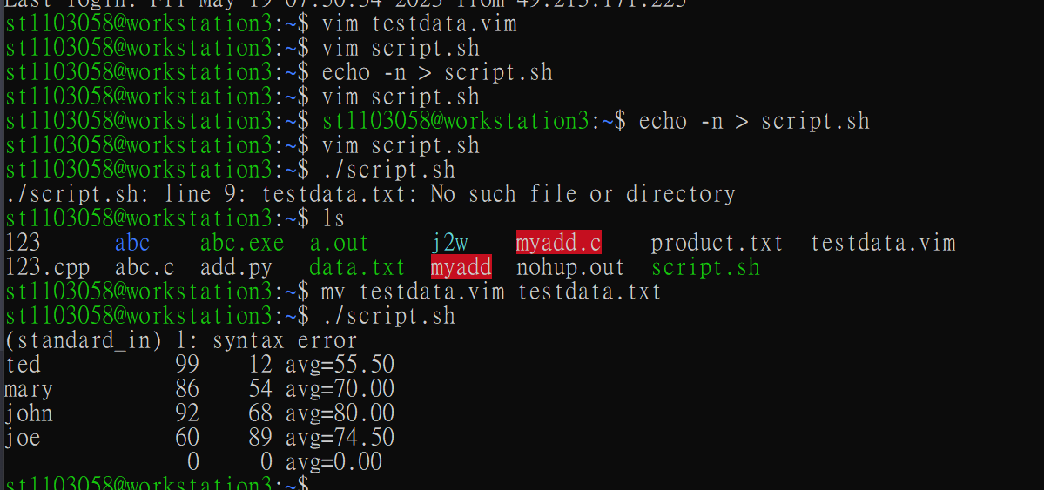

- Write a BASH SCRIPT that takes input a string，Your output is to determines whether it is a palindrom。
Input s: abcba
Output: yes
Input s:abcdefg
Output: no
Input s: never oddo reven
Output: yes
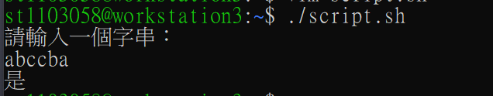
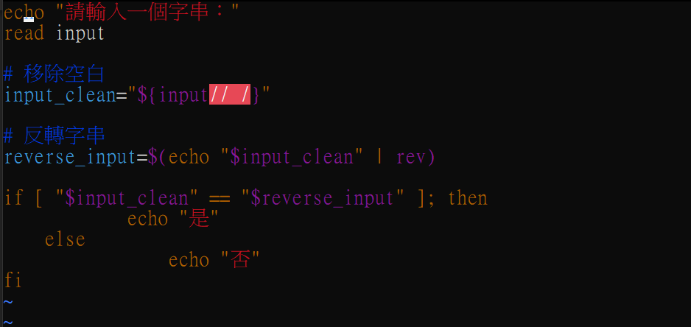
- Write a BASH Script to input the width and height of a triangle, write a function to compute the area of a triangular.
(NOTE: Must write a Function name AREA() and pass two parameters to this function)

Input width and height: 10 20
Output: Area = 150
Input width and height: 20 40
Output: Area = 400
